|  |  |  |
| --- | --- | --- |
| f |  |  |
| **Benha University** |  | **Faculty of Computers & Artificial Intelligence** |

**BFCAI’S Internal**

**map**

**Computer Science Departement,**

***Project Team***

1. يوسف عبد الرحمن فوزى السيد
2. احمد محمد عباس الشامى
3. يوسف هشام عبد الواحد عبد الهادى
4. يوسف ناصر امام حسن
5. سلامة محمود السيد محمود

***Under Supervision of***

**Dr. Shimaa Ismail**

**En. Mahmoud Mansour**

ABSTRACT

**Purpose :**

This program helps students to know the locations of university auditoriums, halls, laboratories, etc.

It also gives the ability to modify schedule information and student information by college officials.

Background knowledge :

1. Java programming language
2. Graphic user interface ( GUI )
3. Database ( MySQL )
4. Opject orianted programming ( OOP )

Target group :

This program targets..

* students by helping them find places to receive lectures, study groups, etc.
* College officials (university professors, teaching assistants, supervisors, administration managers and student affairs official (by giving them the ability to access and modify student information, lecture dates and curriculum courses.

# Introduction

This application help the students to know their class schedule .It will also help them to find their classes and help them in planning their time during the school day by providing information about: the rooms, halls and university amphitheater where students can find lectures , group study , group exercise and individual assignments. and also the application providing information about the students in the college.

And it also helps the college officials by giving them the ability to access and modify student information, lecture dates and curriculum courses.

# Content of documentation

Content of the application :

* Graphic user interface ( GUI )
* Database ( MySQL )

**Graphic user interface ( GUI )**

First, when the user start the program a window will appear

Contains a..

- two choices ( Student, Admin)

- one button ( Next ) taking you for the next page.

When the user choose “student”

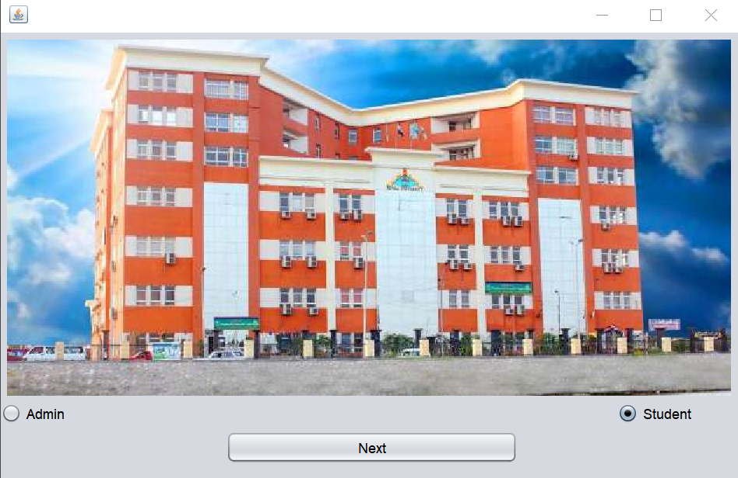

Another window will appear contains buttons of the floors of the building , class schedules , subjects , student info searching tool and tape “about the application” .

The button in the window :

**the floors of the building**

It have simplified map of each floor

* Ground floor

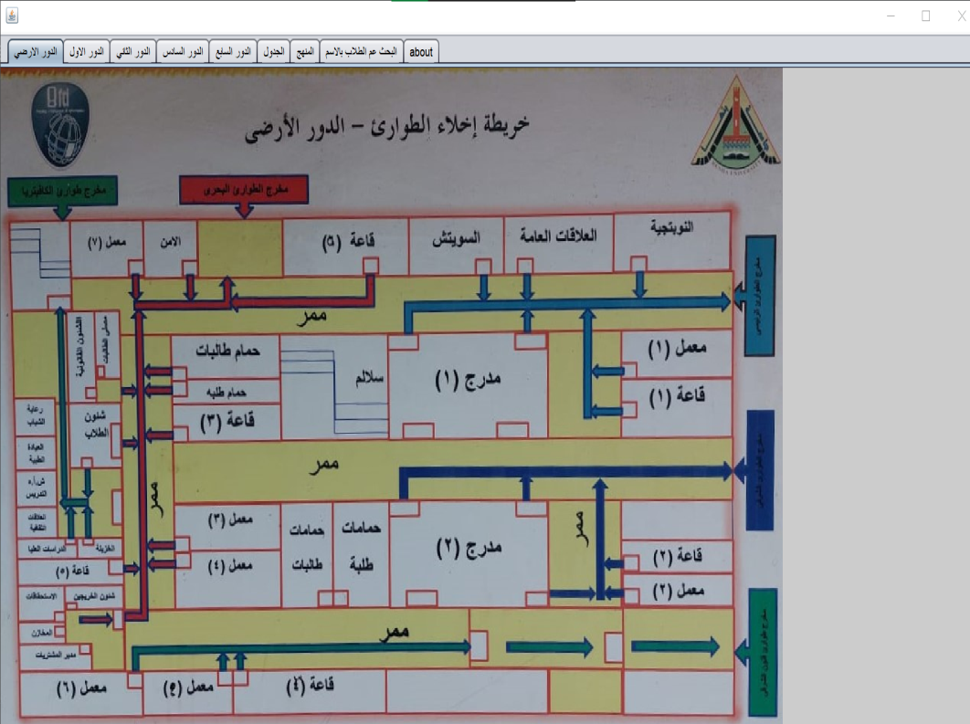

* First floor

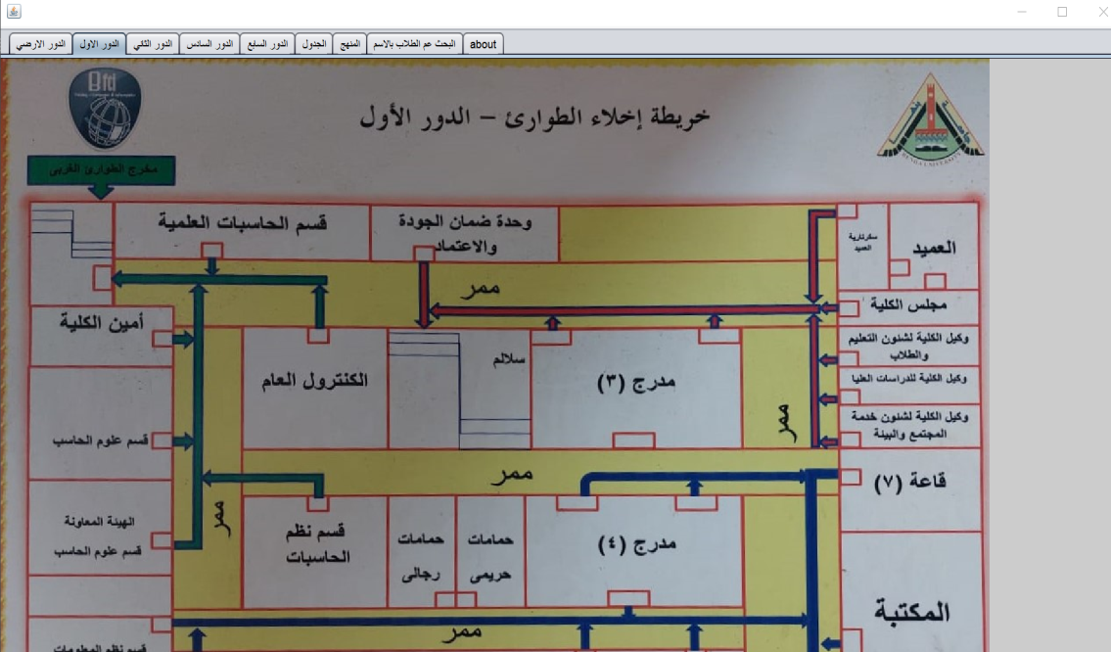

* Second floor

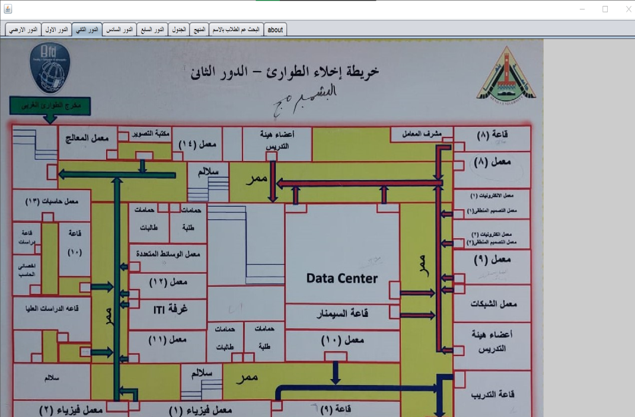

**Class schedule**

It contains class schedules for each day for example..

* Saturday

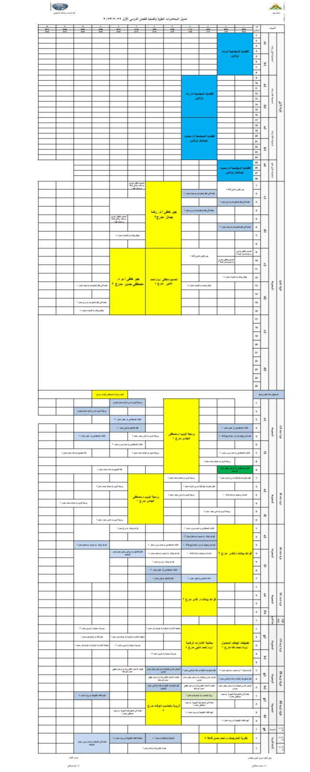

-Sunday

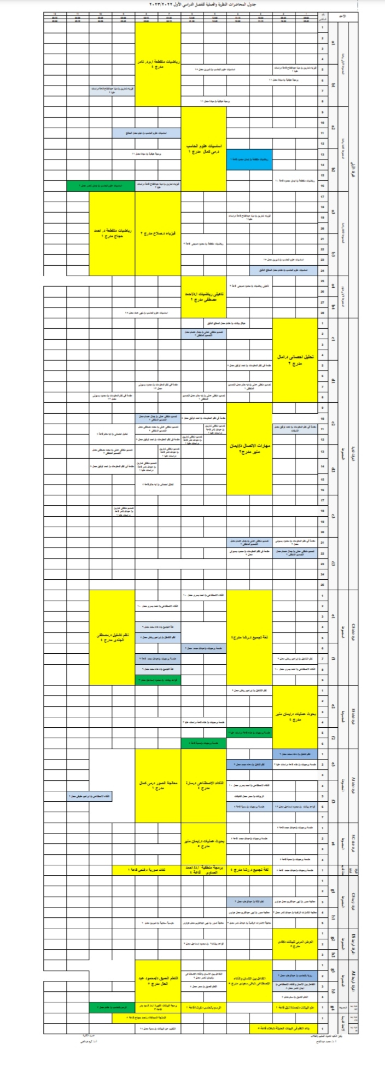

**Subjects**

It contains the subjects for each educational year and its semesters for example..

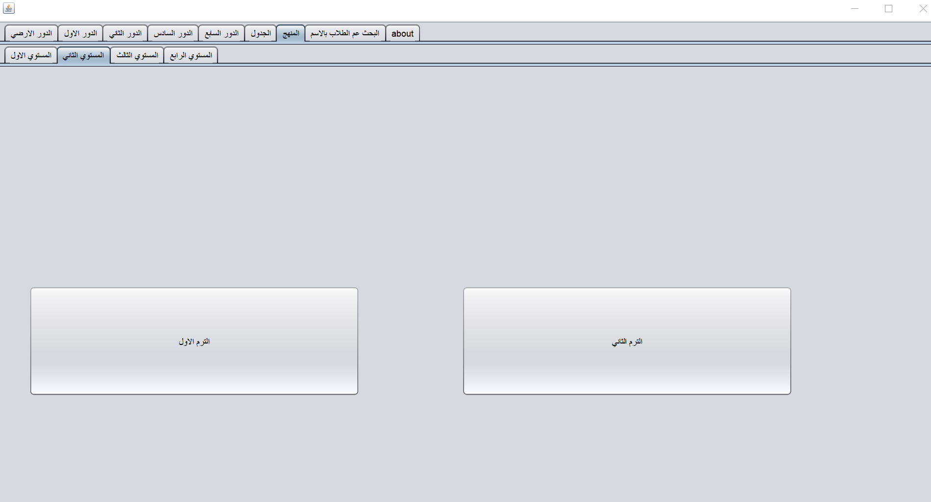

**Student info searching tool**

It contains a searching panel for a student name to search for

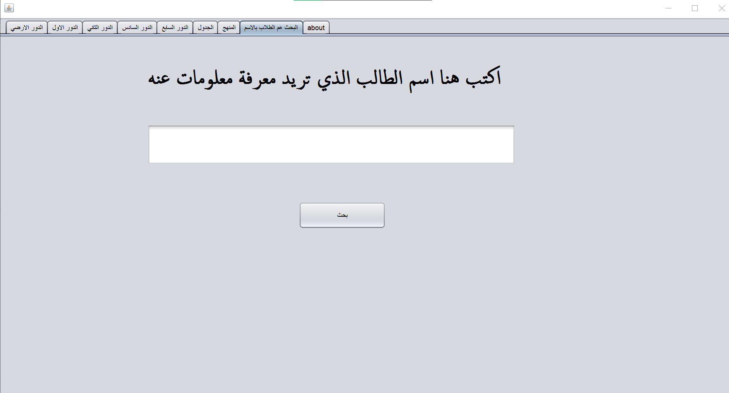

**“about the application” tape**

It contains a little abstract about the program

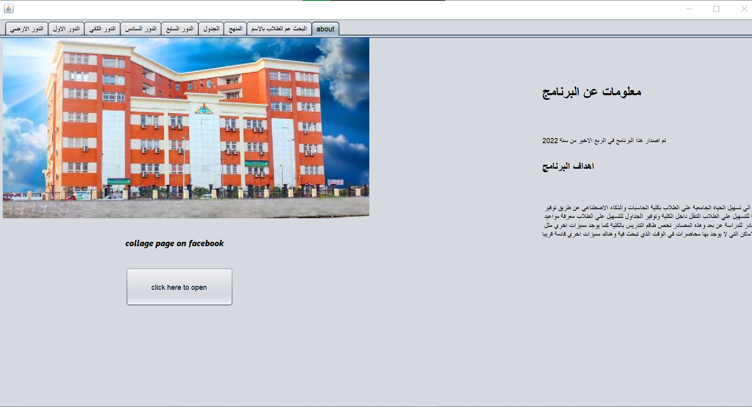

When the user choose “Admin”

|  |  |
| --- | --- |
|  | The window that will appear have a panel to write the password in  And after that the admin can edit the data of the program.  **Database (MySQL)**    **At first we will create the table that we will take the foreign key from it with name subjects the first column will be the primary key with name sub.id and other tables with name ( sub.name, sub .teacher , maximum degree , minimum degree ).**  **Another table with name student will take foreign key with name sub.id from subjects table and the first column that we will create will be primary key with name student ID and other tables ( student name , student level , GPA ).** Conclusion |
|  | The application should be helpfull for the user whoever he is  (student,Professor,officials,etc..) References |

En. Ahmed Tawfik database (MySQL) videos:

https://youtube.com/playlist?list=PLsfs9DojDVqNvHKzrJJcNxSgu0K61pKm4

En. Ahmed Tawfik ( GUI ) videos:

https://youtube.com/playlist?list=PLsfs9DojDVqPycazAm-hcwTZ0T0-kl-9E

En. Ahmed Tawfik java for beginners videos:

https://youtube.com/playlist?list=PLsfs9DojDVqPfzLGBnf0UV3SoUsOfxTQl

Mohammed Eldosoky java for beginners videos:

https://youtube.com/playlist?list=PL1DUmTEdeA6K7rdxKiWJq6JIxTvHalY8f